C-42 description: Jah Mon
1994 Mk 1 (last year of the Mk1)
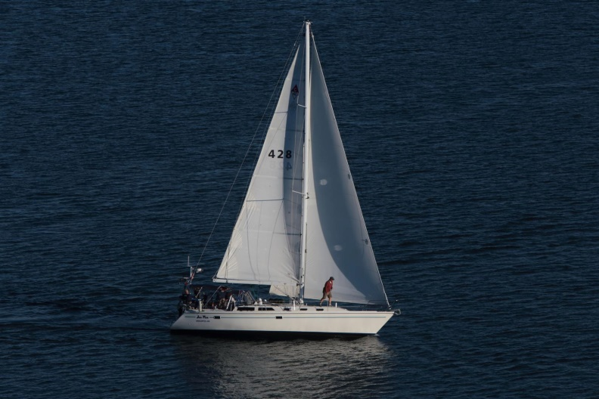

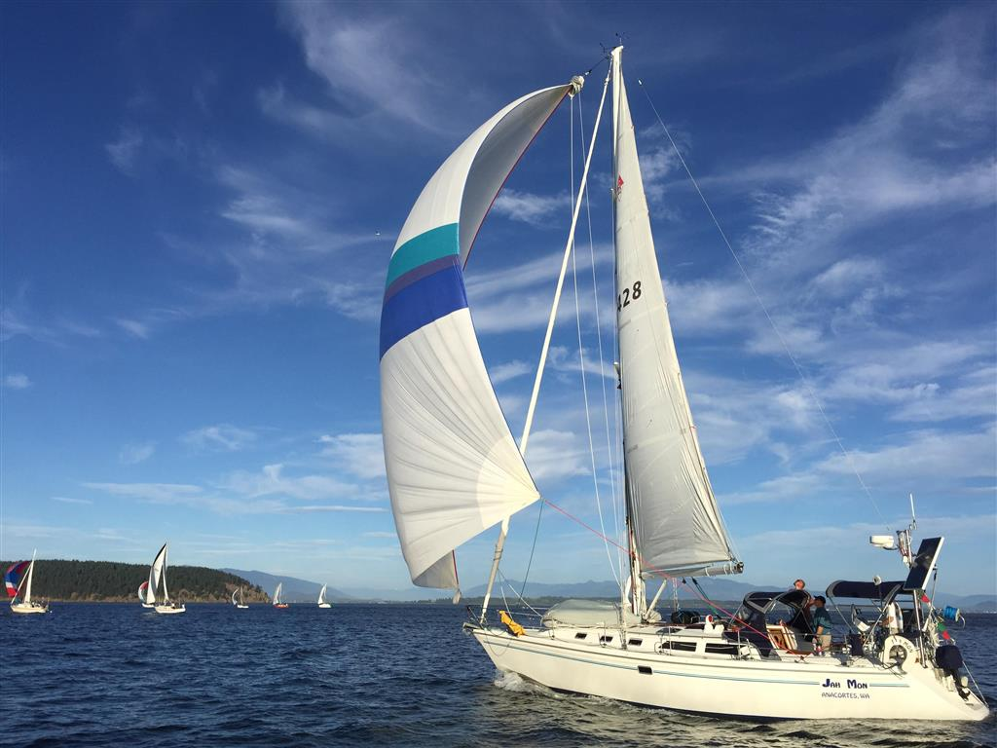
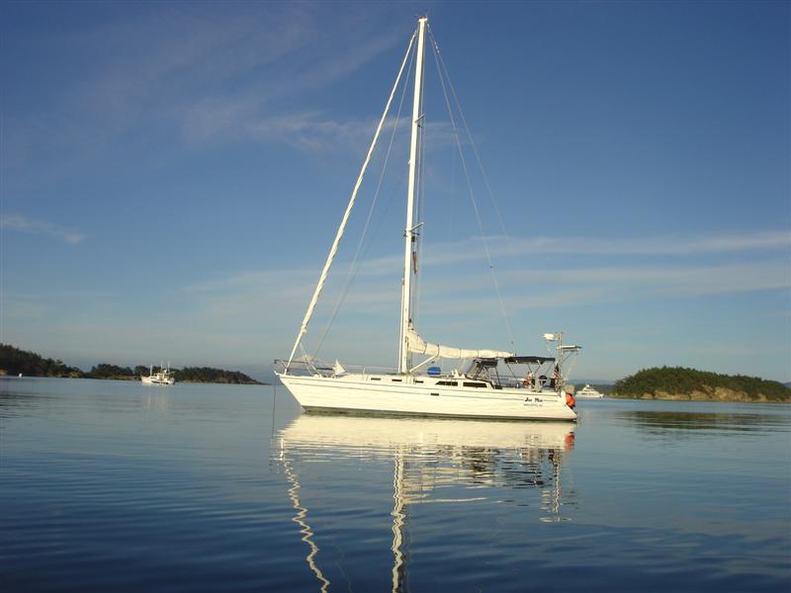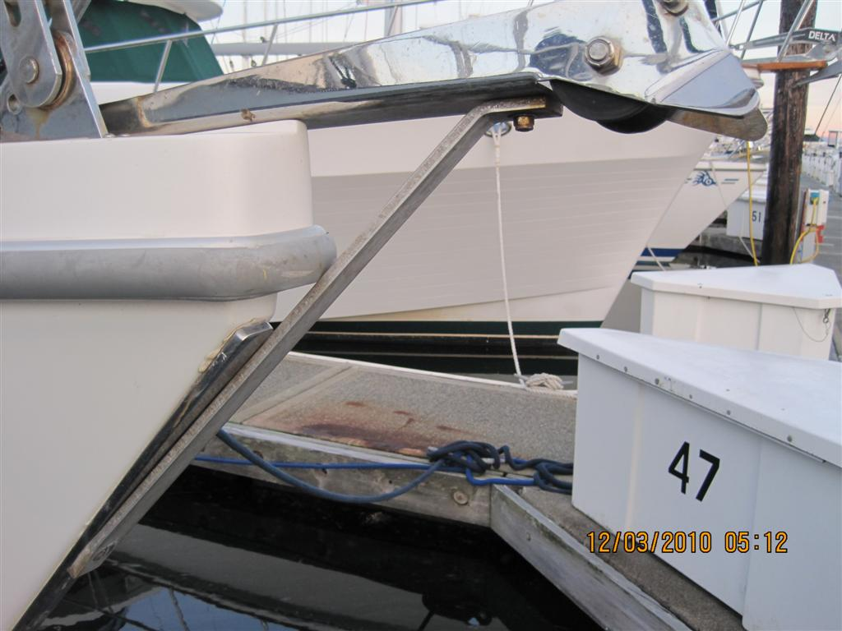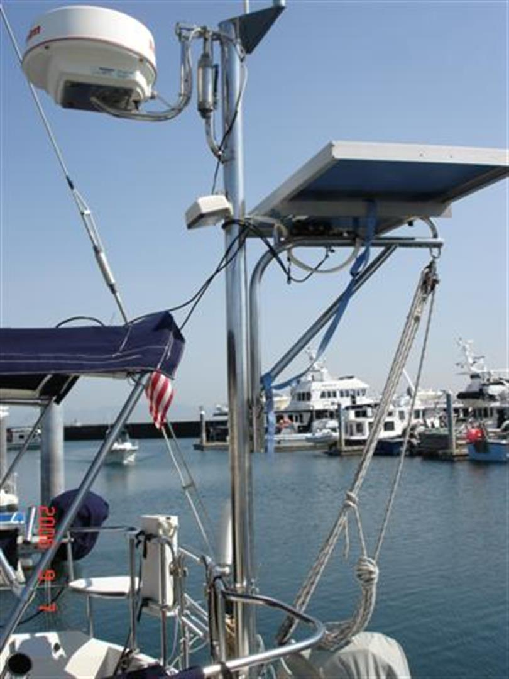
The construction of the Catalina 42 is as sound as any similarly priced and sized boats and better than some. The hull is constructed of a solid laminate of fiberglass and resin with no core materials. The hull is fitted with a structural fiberglass liner that incorporates the cabin sole as well as berth and furniture foundations. The deck is a cored composite with fiberglass and 3/4" end grain balsa wood. Where deck hardware is installed, 1/2" plywood is used instead of balsa wood. The deck and hull are joined in a shoebox fashion flexible adhesives and stainless steel nuts, bolts and washers on eight-inch centers. There is an aluminum rub-rail with vinyl insert fastened at the deck to hull joint with stainless steel screws.
On deck, the Catalina 42 is clean and unobstructed except for the deck hatches and handrails. The anchor windlass is located in a foredeck locker to keep it out of the way when not needed. Rigging shrouds are set well inboard to allow effective sheeting angles and easy passage on either side. The mainsheet traveler is located on the cabin top forward of the companionway and out of the way of the dodger. The cockpit is large with seats that are 6' long and big enough to stretch out in. The helm seat at the transom opens to allow access to a swim platform molded into the transom. There is a folding table in the cockpit forward of the binnacle.
The interior is bright and roomy with beautiful woodwork throughout. There is a head and shower forward where a V-berth cabin might normally be found. Between the main saloon and the forward head is a Pullman-styled stateroom with port berth and starboard hanging locker, chest of drawers and settee. The berth is wide and extends form centerline to the hull side and is 80" in length. The main saloon features a port side dinette with a drop table (for another double berth) and a full galley to port. The navigation station is down the companionway stairs and to starboard. There is a settee to starboard aft of the navigation station.
Accommodations
2 cabin layout. The main saloon is spacious (6’8” headroom), chart table to starboard with additional settee and crescent shaped dinette to port. Forward in the owner stateroom with pullman berth to port, seat and lockers to starboard, head in the forepeak. Guest cabin with ensuite head to the starboard at bottom of companion way stairs. Galley to port. Access to ‘garage” through galley or through lazzerette.

Galley
Port side “U” galley features refrigeration, propane stove and oven. Microwave, deep double sinks
All faucets and drains throughout vessel replaced 2013. Large pantry and other shelves.
Corian counters throughout boat
Head:
- Lectra San sewage treatment system in master, no holding tank, Coast Guard approved
- Raritan electric head fwd (2009)
- Manual Groco head in aft to holding tank with macerator pump out and Y valving to outboard discharge.
- Shower in forward head and on swimstep

Electronics
Simrad 12” touch screen display (2013)(all linked to other NEMA 2000 input through backbone), wet compass (Richie 8”) at helm, Simrad AIS VHF radio (2013)with additional speaker at helm, VHF (Standard Horizon) at nav station, SSB/ham Icom 710 at nav station, Depth and Speed (ST 50 Autohelm), Wind (Simrad (2013)), Stereo (Pioneer (2011) with remote control) with 3.5mm input, Auto Pilot (Autohelm 7000 ST), Radar (Simrad (2017)),
Other: Backstay antennae for SSB, Manuals for all equipment, Blue prints for vessel

Electrical
12vdc system throughout vessel powered by 8 golf cart Gel Cells (2016). Start bank isolator automatic. Batteries charged off diesel, 140 amp Balmar alternator (spare 90 amp alternator backup) and 110v shore power inverter (Xantrex 2500). 110vac system throughout vessel, powered by 110v inlets aft to 110v panel. Powers outlets, water heater and battery charger. Solar panel of 75 watts, on radar tower. LED lighting on dimmers for interior throughout the boat.

Sails
- Mainsail, Full Batten - 2004
- Genoa 140% Furling - 2014
- Jib #3 Furling 110% - 2008
- Asymmetrical ¾ oz. Spinnaker in ATM sock - 2004
- Spinnaker Pole Mounted to Mast
- Sheets, Control Lines and Running Rigging
- Line control locks on cabin top, 4@ side near Lewmar 42 winches (2@)
- Adjustable sheet leads (2014) under load for headsails
- Spare headsail halyard
- External spinnaker halyard
- Furler
- Upgraded (2012) Garhaurer traveler, adjustable under load
- Retractable lazy jacks
- Harken batten cars for main

Deck
Walk thru transom with large T-shaped cockpit, Pedestal wheel steering, Pushpit 1” rails with corner seating extend to midship, lifelines (2015) and stanchions, Contrasting molded in non-skid, Anchor locker in bow with anchor roller, SS handrails , teak companionway boards, 2-Dorade vents, 9-Hatches w/ screens and sun covers.

Additional
Dodger (Iverson, 2014) with bimini and connector with glazing. Electric anchor (Maxwell 800) windlass, Pedestal cover, Covers (sunbrella) for all exterior wood, Cockpit cushions (2014), corner seat cushions, helm booster cushion (2009), companion way canvas cover for cruising, saloon doors with screen for companion way, Basic safety and mooring package, Double SS lifelines (2016) w/ P&S gates, walk thru transom with custom swim ladder, hot and cold cockpit shower, 10 opening ports and 9 overhead hatches, SS 1” dia. Push Pit goes forward to the boarding gates near max beam. Magma BBQ (Newport model) with cook prep table and refillable aluminum propane bottle mounted on the push pit.
Professionally maintained and serviced. Receipts for the past 13 years.

Additional Specs, Equipment and Information:
Specs
Keel: Fin
Dimensions
LOA: 41 ft 10 in
Beam: 13 ft 10 in
LWL: 36 ft 0 in
Maximum Draft: 7 ft 0 in
Displacement: 20500 lbs
Ballast: 8300 lbs
Engines
Total Power: 50HP
Engine 1:
Engine Brand: Yanmar
Year Built: 1994
Engine Model: 4JHB2E
Engine Type: Inboard
Engine/Fuel Type: Diesel
Propeller: Feathering Autostream SS propeller
Drive Type: Direct Drive
Engine Power: 50 HP
Tanks
Fresh Water Tanks: 3 104 Gallons, 50, 27, 27
Fuel Tanks: 1 Aluminum (38 Gallons), 1 Aluminum (22 usable gallons)
Holding Tanks: 1 Plastic (46 Gallons)
Accommodations
From the companionway steps, the galley is to port, with a walkway aft leading to a supply storage locker. There is a pantry and a custom door to enable access to the engine water pump and the rear of the engine, both off the walkway. Across from the galley is the guest head, with the guest stateroom adjoining aft, comprising a double berth, hanging locker and drawers with an opening hatch and 2 portlights.
Moving forward to the salon, the U-shaped dinette is to port and a curved settee to starboard, both upholstered. The nav station is forward of the starboard settee. There are overhead grab rails, 4 opening hatches and 2 opening ports. Rugs (included) accent the teak and holly sole.
Forward of the salon to port is the pullman master berth with under bed storage.. Here there are 2 opening hatches and 4 opening ports. Across from the pullman berth are 2 hanging lockers with three drawers. The master head is in the bow and comprises an electric head connected to a Raritan Sewage Treatment system, vanity and a shower area with seat.
.

Galley
- Adler Barbour refrigerated ice boxes (2)
- Princess 3-burner propane stove w/oven
- Princess turntable microwave
- Double SS sinks
- Pantry (located in walkway aft)
Electrical
- 8 gel cell batteries in three locations, 800 amp capacity
- One 100 watt aimable solar panel on a custom SS radar pole on stern
- Xantrax Smart Link 2000 battery monitor
- 2500 watt InverterXantrax/ Charger
- Balmar 140 amp output alternator on engine
- Spare 90 amp alternator
- Custom electric control panel main cabin
- Custom LED cabin lights forward and main and guest cabin
- Night vision red lights interior
- Toaster

Electronics
- New Simrad Radar (2018) and12” Simrad plotter (2013) combo
- Autohelm 7000 autopilot
- Standard Horizon VHF 2nd backup in cabin
- Simrad VHF (2013) radio with AIS recognition tied to Plotter
- DVD Receiver/Radio with remote
- Autohelm knot meter
- Autohelm depthsounder
- Simrad (2103) wind gauge
- SSB, Icom
All Simrad units can be read and controlled by Ipad

Rig and Sails
- Full battened main (2004) with Harken batten cars and lazy jacks
- Free footed main with adjustable clew from cockpit
- 140% Ullman headsail (2014)
- 115% Ullman headsail (2008, rarely used)
- Cruising genaker with ATN sock (2004)
- Extendable (18-25’) HD whisker pole mounted on mast with topping lift
- 2 x Lewmar 52 winches
- 2 x Lewmar 42 winches
- 2@ double handle winch handles, one single handle, and a spare.
- Garhauer boom vang
- Garhauer (2011) HD main sheet traveler
- Garhauer headsail sheet turning blocks
- Garhauer adjustable genoa sheet leads (2014)
- SeaFurl 3000 headsail furler
- Halyard retainer for furler
- Spinaker bail mounted in front of the forestay at top of mast
- Spare genoa halyard
- Slab reefing for two positions

Engine and Running Gear
- Yanmar 4JHBE 50 hp, 3026 hours (2018)
- Propshaft, PSS dripless shaft seal, coupling, and cutlass bearing 2018
- Autostream SS feathering three bladed prop
- 7 mpg at 7k

Decks and Additional
- Outboard lift (4:1) on yard mounted on radar tower
- Dodger, connector, bimini (2014, Iverson)
- New life lines installed by Anacortes Rigging 2016, SS
- 10' Aluminum RIB on foredeck (2011)
- 10 hp 2-stroke Mercury outboard w/doyle fins (2002)
- Aft head is a manual Groco to aft holding tank
- Fwd head is electric Raritan feeding to a Electra San sewage treatment, no holding tank needed.
- Teak grates in both heads
- All faucets replaced 2014 to single handle controls
- Hot water heater (12 gallon, 2015) 110v and engine heated
- Shower in forward head and on swim step
- Spectra Water Maker 1600, complete rebuild 2011, unused since.
- Webasto airtop furnace, approx. 1 qt. an hour diesel use.
- Corian counters throughout boat.
- Leather wrapped wheel and mast boot.
- Radar reflector
- Bow cover for sun
- Interior rugs
- 4:1 boom preventer
- Throwing PFD
- MOB retrieval system
- Magma BBQ (Newport model) with 2 gallon aluminum tank)
- Spare 3 gallon aluminum propane tank ( 2@ total)
- Hatch screens

Anchor locker
- 44 lb Bruce Primary anchor
- 200’ of 5/16” chain daily use
- Maxwell 800 windlass with both rope and chain gypsy
- UP and DOWN switches plus manual clutch
- Salt water wash down
- Reinforced bow roller for tacking spinnaker
- Spare Danforth anchor with 300’ of rode and 30’ of chain in lazzerette
- Lunch Danforth with 100’ of rode and 20’ of chain that mounts on push pit
- Dinghy anchor

