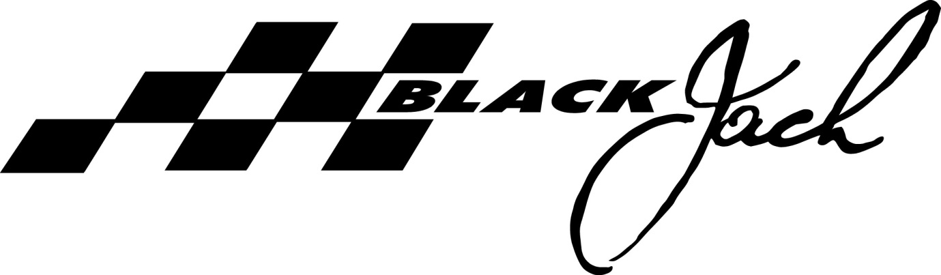
MEDIA RELEASE 15 JULY 2013
New Black Jack christened and declared “an all-out race boat”
A large turnout of family and friends gathered at Rivergate Marina on the Brisbane River on Saturday morning, marking the start of the next chapter of the Black Jack story.
Queensland’s highest profile grand prix yacht racing team has upped the ante with a current generation Volvo 70 bought from Europe and remodelled for Australia’s leading coastal races.
Motor racing legend Sir Jack Brabham, a close friend of Black Jack’s owner Peter Harburg, christened the boat with champagne and addressed the assembled guests. The octogenarian spoke of his early realisation that preparation and continually updating his equipment was the key to staying competitive throughout his eminent career.
“We are updating and we are confident we’ll keep the Black Jack name up there,” said Harburg at the launch.
When Harburg told Brabham he’d bought the new boat, he requested the great man’s permission to stick with the ‘Black Jack’ moniker, the nickname given to the triple world champion in the 1950s.
“We recognise Sir Jack’s spirit and his tremendous achievements in racing,” said Harburg. “He had a gritty determination and the Black Jack crew carries this same trait. He’s chuffed that we have named another boat after him and that we capture his spirit in the way we put a campaign together.”
After taking Sir Jack for a motor and giving him a turn on the helm, the crew left the crowd ashore and headed to the open water of Moreton Bay where they first hoisted sails in light air on a stunning winter’s afternoon.
“We were impressed with the acceleration, as you would expect we were consistently sailing higher than the wind speed…it’s an all-out race boat,” said Harburg of their debut sail.
Tacking and gybing with dagger boards and a canting keel is a whole new ball game for the 15-strong crew and they spent their maiden sail practising manoeuvres.
This Friday the delivery crew will take the boat to Sydney where the full crew complement will line up on July 27th for their first match-up with the southern states in the Audi Sydney Gold Coast yacht race.
They will use the original Volvo 70s sails that came with the purchase and over time will replace the wardrobe.
Skipper Mark Bradford acknowledges the lack of time on the boat pre-race isn’t ideal. “As the boat is broken in, the input of our specialist VO70 sailors and the experience and nous of the core crew will be crucial.”
At Saturday’s launch the new Black Jack 70 was blessed by a local priest, another friend of the owner’s. The crew cheekily asked could they put in an order for fair winds for their eastern seaboard circuit of events, including the notorious Rolex Sydney Hobart. They were told that unfortunately these sorts of favours couldn’t be arranged.
The new Black Jack‘s stats:
Length: 70 feet/21.5m
Beam: 5.7m
Weight: 14,500kgs
Mast height: 32m
Designer: Juan Yacht Design
Builder: King Marine
Made from: Carbon fibre
Year launched: 2011

Black Jack Yachting

Further information:
Mark Bradford m. 0414 931 961 or mark@au.northsails.com
Lisa Ratcliff m. 0418 428 511 or lisa@occ.net.au

