Royal Forth Hoosiers win 65th Wilson Trophy

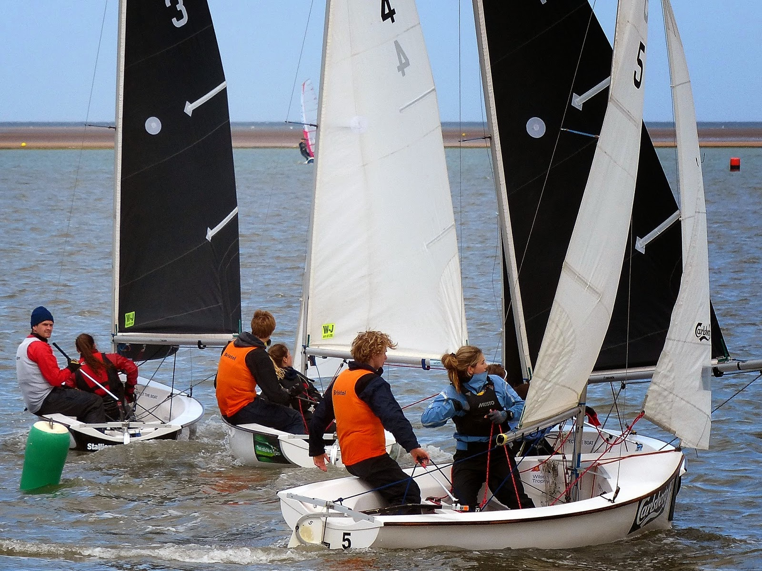
© Jane Bell

The 65th Wilson will certainly go down in history as one of the windiest on record since the competition began. After a delayed start due to strong winds on Friday 9th May, the 32 teams prepared themselves to go racing. A weather window appeared later in the afternoon and into Saturday which allowed the completion of 13 rounds of sailing amounting to 208 races in total. As Saturday progressed, with winds gusting up to 38 knots, the top eight teams began to emerge with many famous names amongst them.

However, it was the Royal Forth Hoosiers (Tim Saxton, Rob Friend and Mark Powell) that, by the end of racing on Saturday, had taken the lead from Paddington Bears (Leo Dixon, Ben Field and Paul Campbell-Jones).

Given the blustery conditions the race management team was highly impressed by competitors’ boat handling skills and the care they took with the boats over the weekend. Damage was minimal and a testament to the hard work put in by the boat preparation team and the beach master before and during the event.

Sunday dawned with winds of over 30 knots and, with the occasional tempting lull, the race management team constantly reviewed the situation, desperate to get back to sailing. However, this was not to be and eventually at 1pm racing was abandoned. The overnight leaders therefore became the winners and another new name now appears on the coveted Wilson Trophy.

David Taylor, commodore of West Kirby Sailing Club, said: “It was a great weekend of sailing, we were delighted to see so many old faces as well as so many new. Unfortunately the weather got the better of us and we were unable to complete any more racing on Sunday, but this did not dampen anyone’s spirits.

“We feel this year’s competition will be remembered as a Wilson Trophy with some fantastic sailing in adverse conditions, with a well-deserved winning team. We look forward to seeing you all again next year.”

Final results were as follows:

WINNERS: Royal Forth Hoosiers
Tim Saxton
Rob Friend
Mark Powell
Isobel Walker
George Clark
Emma Lombard

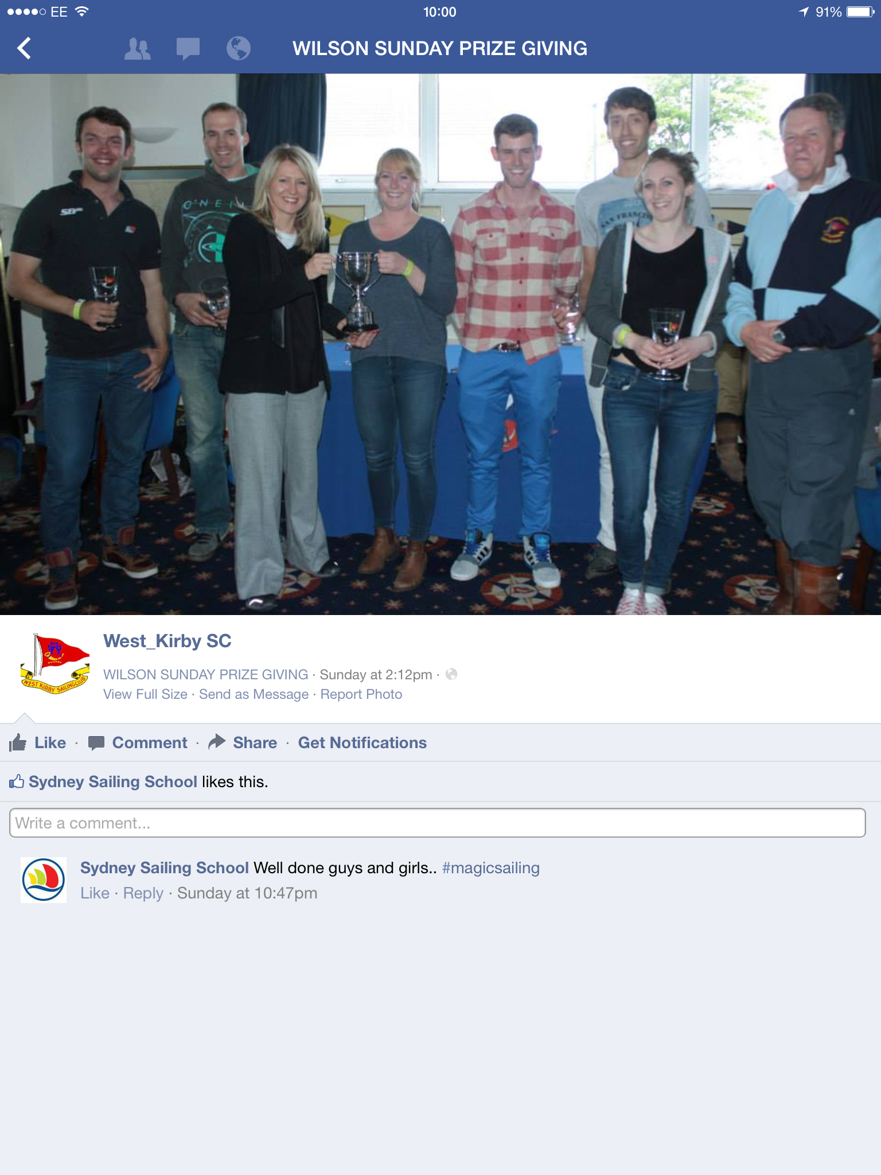
© Alan Jenkins

RUNNERS UP: Paddington Bears
Ben Field
Leo Dixon
Paul Campbell-James
Tom Foster
Kate Fairclough
Maria Stanley

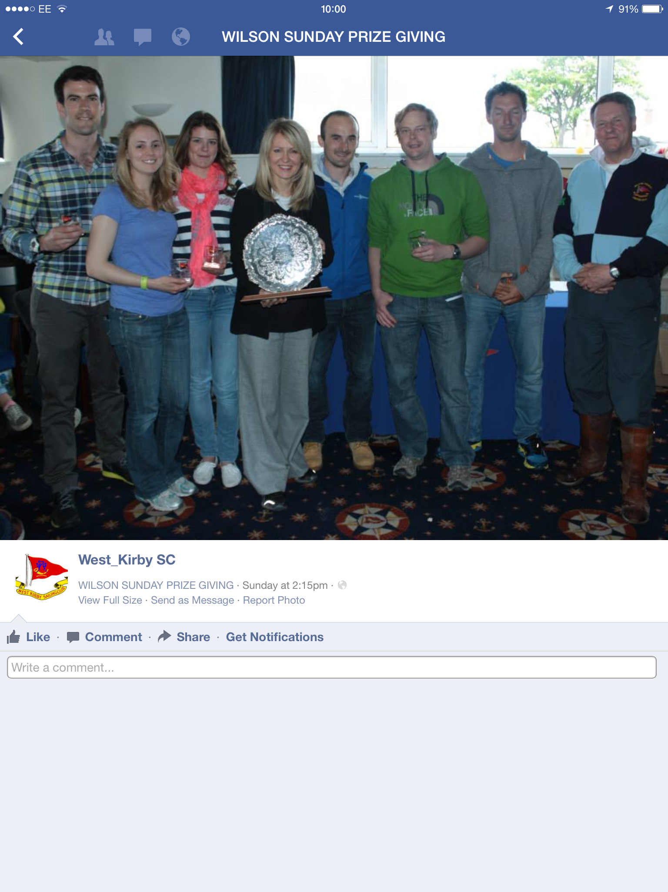
© Alan Jenkins

WILSON PLATE: Royal Thames Blue
Phil Derry
Guy Stephens
Ben Gratton
Kathryn Twemlow
Catherine Cherry
Ben Rahemtulla

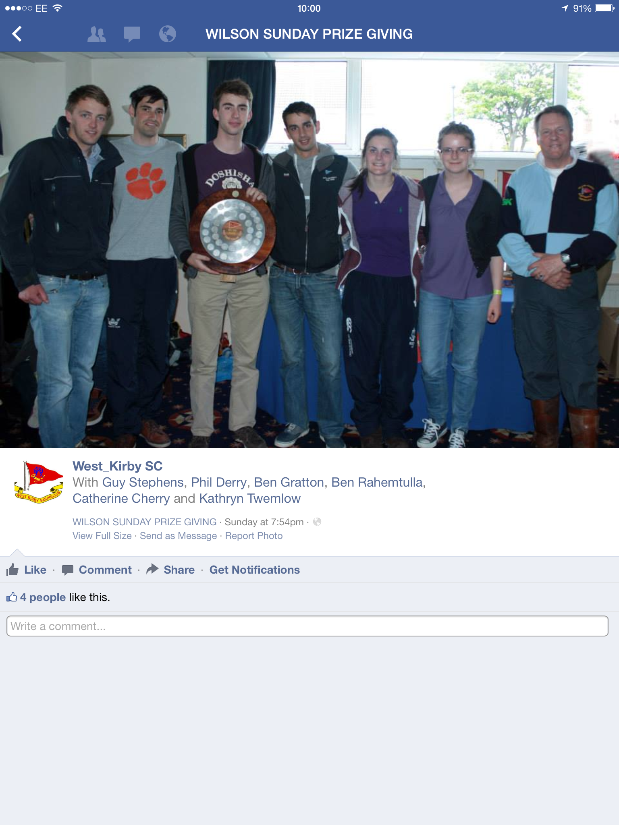
© Alan Jenkins

ERIC TWINAME MEMORIAL UNDER 21 TROPHY: Royal Thames Red
Sam Jenkins
Josh Adams
Guy Dixon
Thea Crawshaw
Nick Upton
Joe Gough

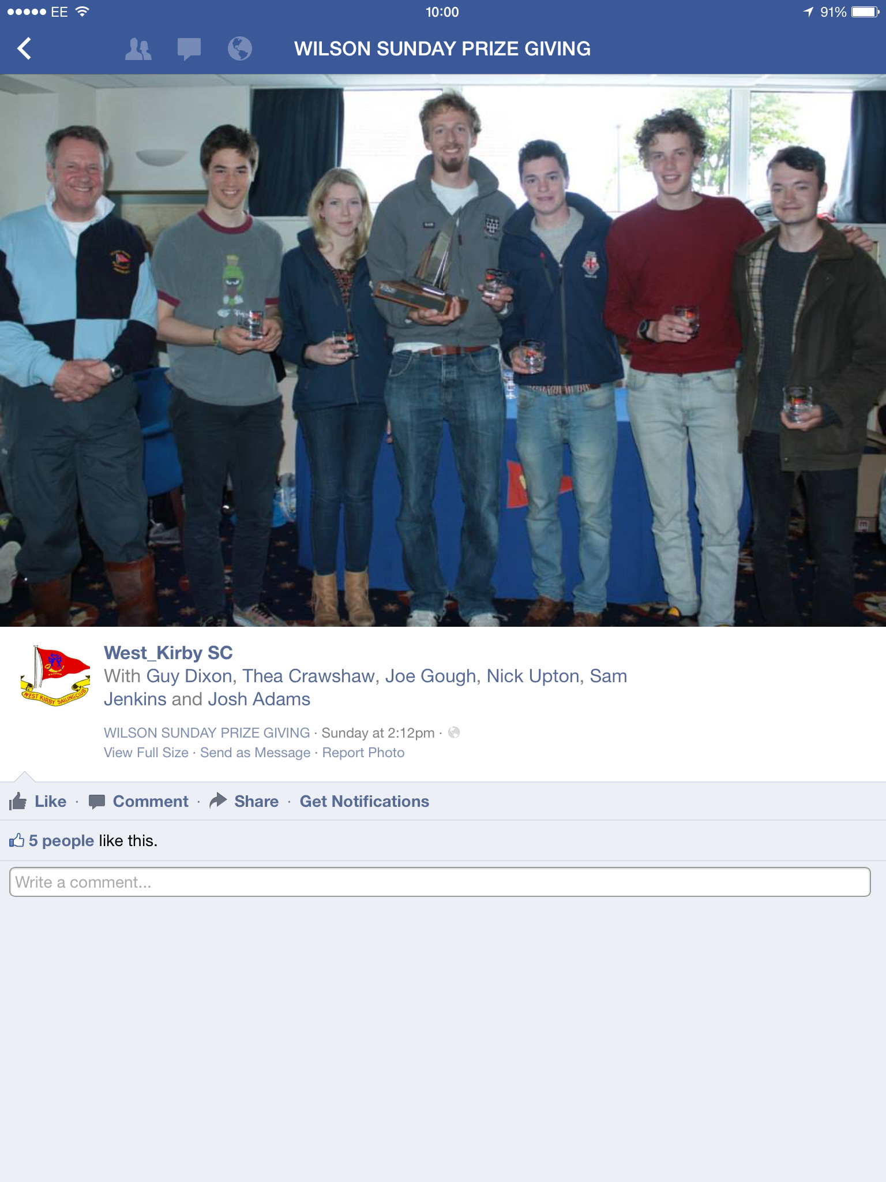
© Alan Jenkins

THE JOYCE EVANS MEMORIAL TROPHY for the best crew was awarded to Tom Foster from Paddington Bears

The 66th Wilson Trophy will be held on the 8th, 9th and 10th May 2015.

– ENDS –

