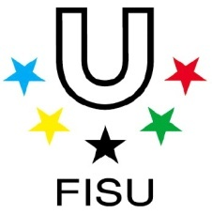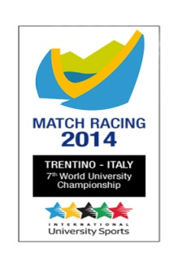
7th World University Match Racing Championship
LAGO DI LEDRO (Italy) June 29th to July 5th2014

RESULTS

OPEN CATEGORY

1 USA SNOW
2 AUS1 GILMOUR
3 FRA QUIROGA
4 JPN ICHIKAWA
5 SIN2 LEE
6 ITA GALATI
7 SIN1 LIU
8 GBR2 MILLER
9 TUR KARAHAN
10 POL SADOWSKI
11 AUS2 GRIFFIN
12 FIN RONNBERG
13 CAN1 GARDNER
14 RUS KATAEV
15 GBR1 WILKINSON
16 GER MAIER
17 BRA GROCHTMANN
18 ITA2 CAVALLARI
19 CAN2 HEARST

WOMEN CATEGORY

1 GBR VOSE
2 FRA COURTOIS
3 BRA1 PONCIONI MOTA
4 SIN1 LIM
5 ITA WETZL
6 AUS2 STROINOVSKI
7 ITA WETZL
8 AUS1 MCCALL

Principal race officer Chief umpire
Roland GALLIOT Bruce HEBBERT

