HKSF Selection Trials
HKODA NATIONAL CHAMPIONSHIP 2014
22nd and23rd November 2014

PRESS RELEASE

On November 22nd and 23rd, the Hong Kong Sailing Federation together with the Hong Kong Optimist Dinghy Association and the Hong Kong Sea School Association organized the Hong Kong National Optimist Championship 2014.
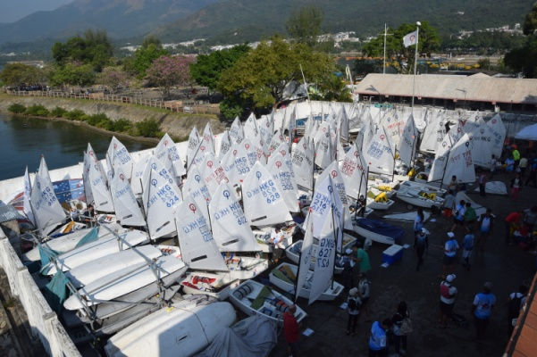
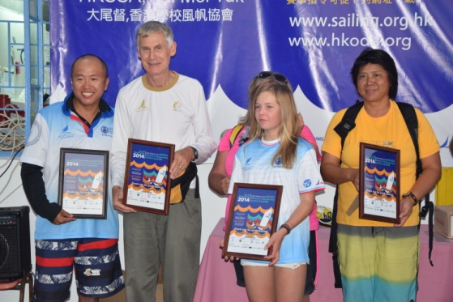
For the first time since its inception in the mid 80’s this annually recurring event took place in Tai Mei Tuk in the Tai Po area. It was an event for the record books: Never in its history had so many sailors participated: More than 90 sailors aged between 8 and 15 took part. Also for the first time, there were international participants from Finland, Macau, Mainland China and Taiwan.
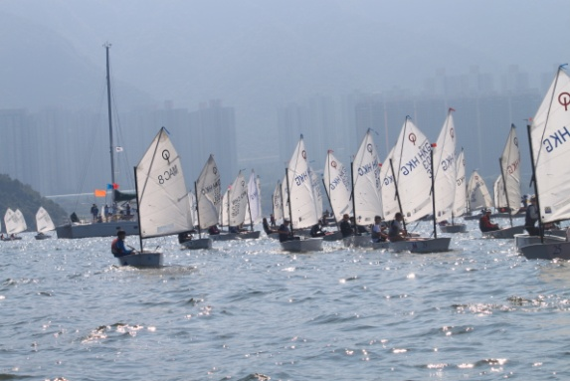
The event took place over 2 days and a total of seven races were sailed. The organizers could not have asked for better conditions. Sunshine and good winds under the watchful eyes of Guan Yin made for ideal competition conditions. The competition was fierce but fair and the winner was only decided in the last race. After the final finish, last year’s winner Calum Gregor, was again crowned The Hong Kong National Optimist Champion with only 2 points separating him from no. 2 Thorwen Uiterwaal and 5 points from no. 3 Dolf Hendriksen.
