The One Ton Revisited entries to date are.-
Yacht Owner/Skipper Sail # Design LOA Built Builder
Panther (NZ) J. Burns C101 S&S 36’ 4” (11.07m) 1968 Salthouse
Pacific Sundance (NZ) B. Hyde NZL 5281 Farr 40’3” (12.28m) 1983 Cookson
Rainbow II (NZ) * C. Bouzaid C96 S&S 36’ (10.97m) 1966 Carter
Result (NZ) B. Hill 2998 Lidgard 36’ (10.97m) 1977 Lidgard
Revolution (NZ) A. Wallis/M. Cossey NZL 4697 Farr 36’ (10.97m) 1984 Land
Wai Aniwa (NZ) * R. Foley 1280 Carter 39’ 4” (11.98m) 1970 Steel Yachts & Launches
Young Nick (NZ) C. Hopkins 1185 S&S 36’ 6” (11.13m) 1970 Wilson

* One Ton Cup winners

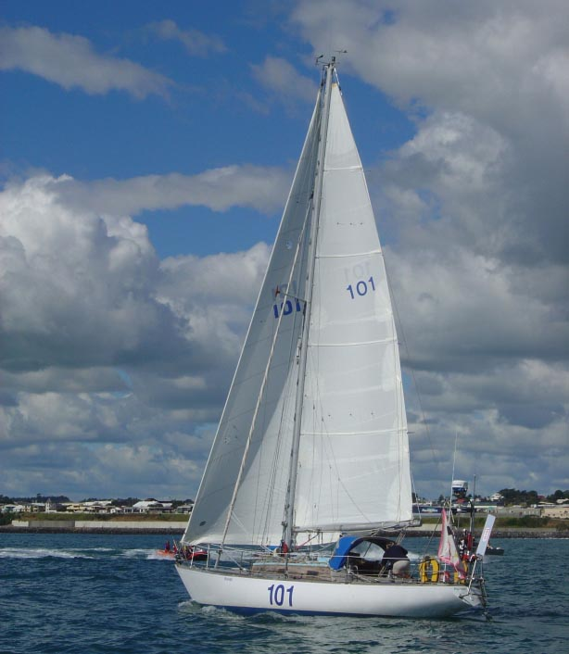
Boat: Panther
Owner/Skipper: J. Burns
Sail #: C101
Design: S&S
LOA: 36’ 4” (11.07m)
Year Launched: 1968
Builder: Salthouse
Construction: Kauri

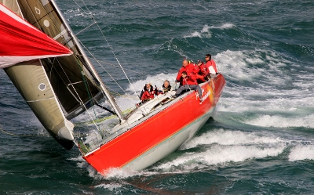
Boat: Pacific Sundance
Owner/Skipper: B. Hyde
Sail #: NZL5281
Design: Farr
LOA: 40’ 3” (12.28m)
Year Launched: 1983
Builder: Cookson
Cunstruction: GRP/Kevlar

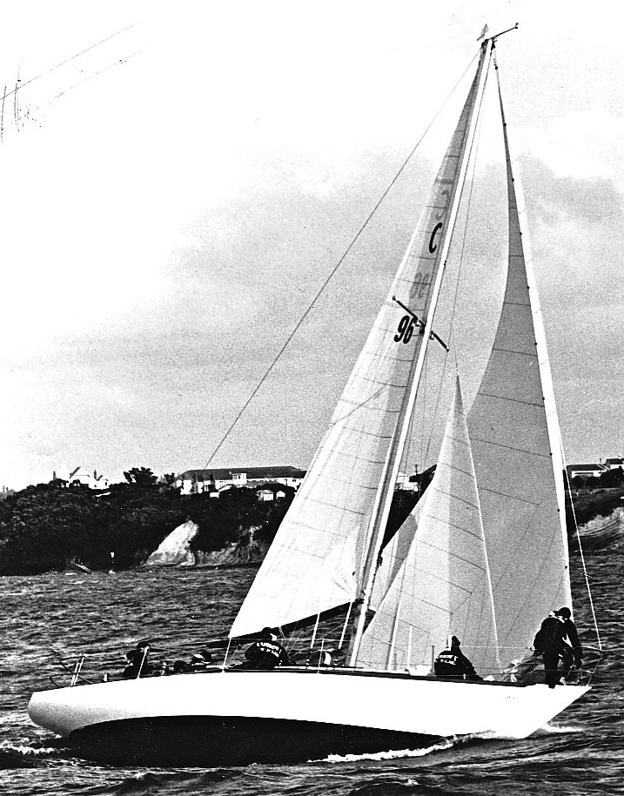
Boat: Rainbow II
Owner/Skipper: C. Bouzaid
Sail #: C96
Design: S&S
Loa: 36’ (10.97m)
Year Launched: 1966
Builder: Carter
Construction: Kauri

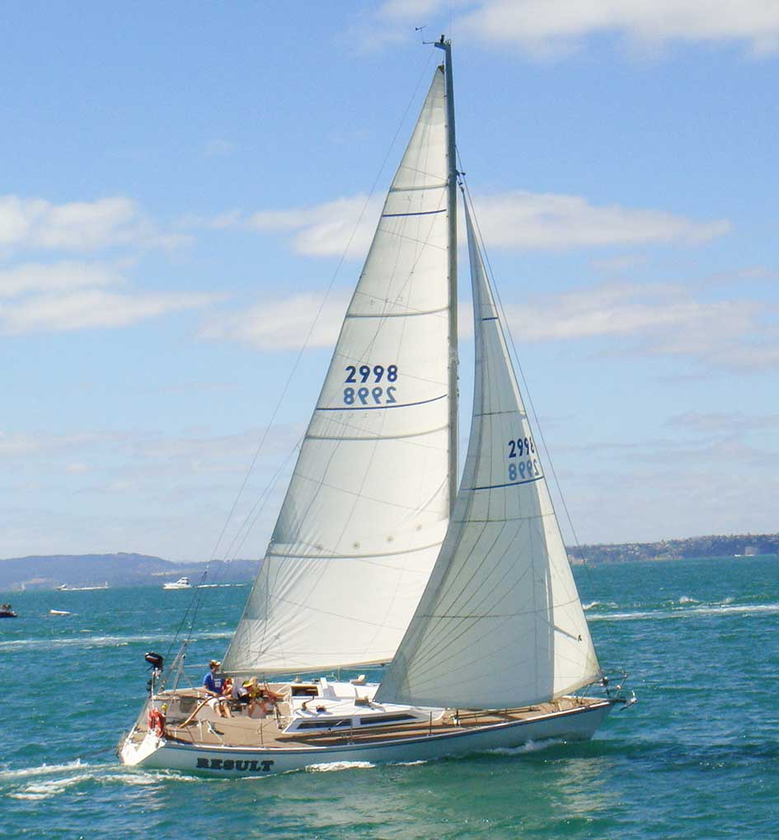
Boat: Result
Owner/Skipper: B. Hill
Sail #: 2998
Design: J. Lidgard
LOA: 36’ (10.97m)
Year Launched: 1977
Builder: Lidgard
Construction: Kauri

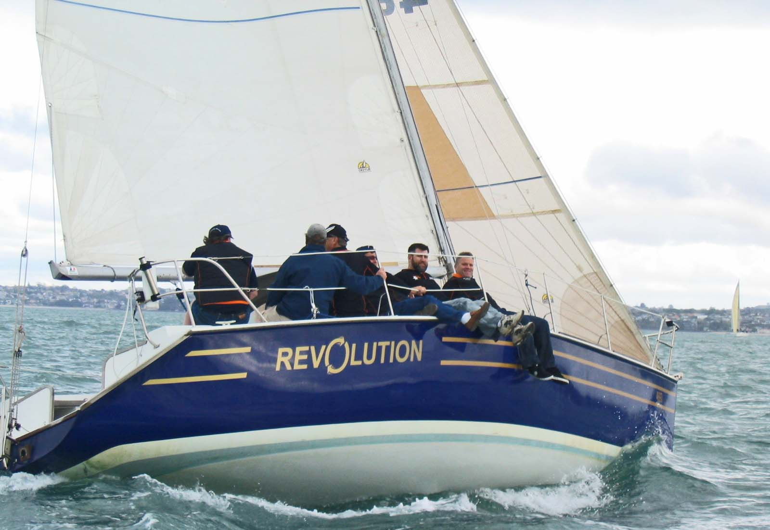
Boat: Revolution
Owner/Skipper: A. Wallis/M.Cossey
Sail #: NZL4697
Design: Farr
LOA: 36’ (10.97m)
Year Launched: 1984
Builder: Land
Construction: GRP

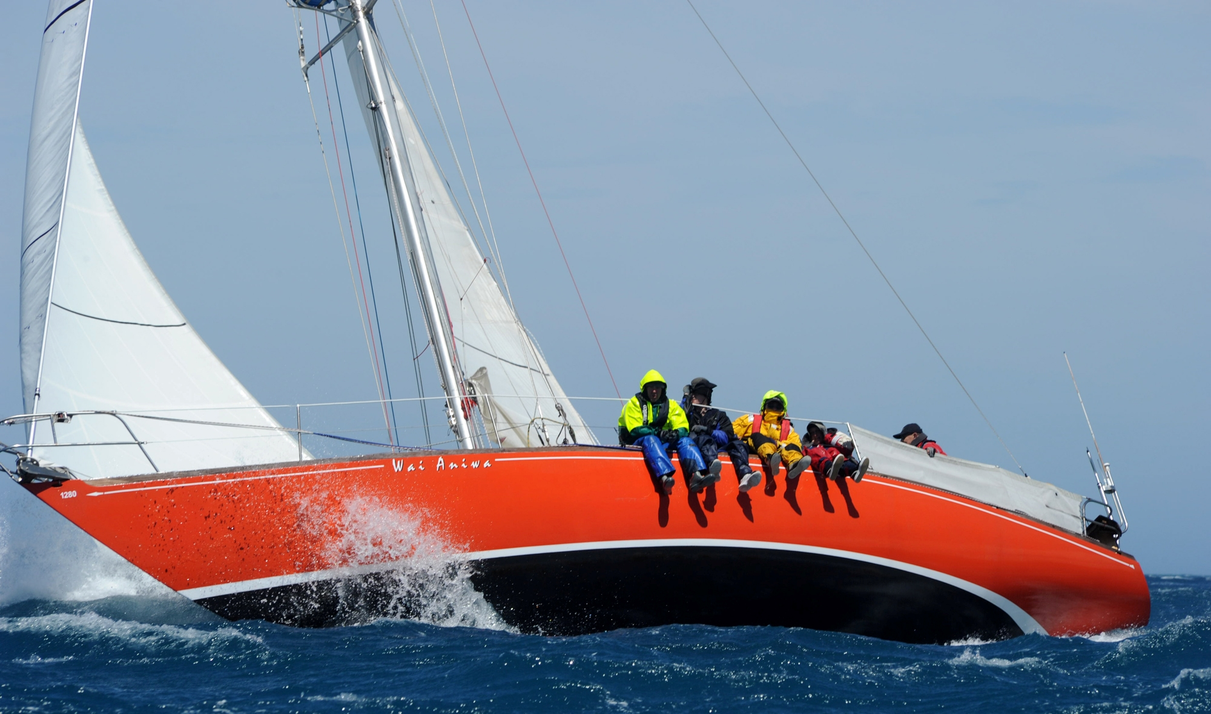
Boat: Wai Aniwa
Owner/Skipper: R. Foley
Sail #: 1280
Design: Carter
LOA: 39’ 4” (11.98m)
Year Launched: 1970
Builder: Steel Yachts & Launches
Construction: Aluminium

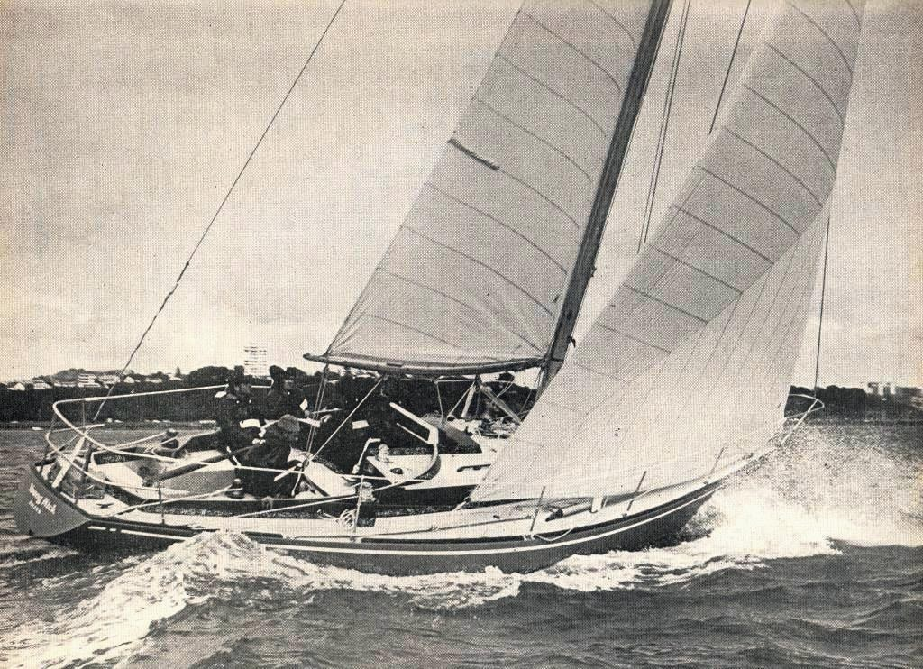
Boat: Young Nick
Owner/Skipper: C. Hopkins
Sail #: 1185
Design: S&S
LOA: 36’ 6” (11.13m)
Year Launched: 1970
Builder: Wilson
Construction: Kauri

